Steps taken to create these groups

1. Cleaned data set – removed all overlapping subjects (same person, different number depending on grant)
2. Checked distribution of measures used in the composite
3. Created a complete cases data frame (n = 335) for the model without vocabulary. Complete cases for the following items:
   1. SubjectID
   2. Age
   3. WASI Matrix reasoning
   4. Word Attack
   5. Letter-Word
   6. Reading Comp (WJ3)
   7. TOWRE words
   8. TOWRE nonwords
4. Checked distribution of the composite variables in the complete cases data frame above (named nv.cc) using dagoTest.
   1. Word Attack
      1. Omnibus <2.2x10^-16
   2. Letter-Word
      1. Omnibus 8.31x10^-13
   3. TOWRE words
      1. Omnibus 3.919x10^-14
   4. TOWRE nonwords
      1. Omnibus 1.246x10^-6
5. Prepped for centering, scaling, and transforming of the composite variables.
   1. Word Attack
      1. Lambda: 5.5
   2. Letter-Word
      1. Lambda: 5.75
   3. TOWRE words
      1. Lambda: 1.5
   4. TOWRE nonwords
      1. Lambda: 1.5
6. Looked at distribution of Word Attack and Letter-Word; their lambdas are above 4.
   1. Word Attack (one subject with score of 0) 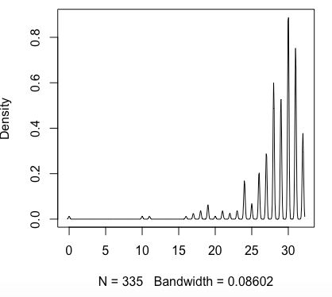
   2. Letter-word (no obvious outliers)

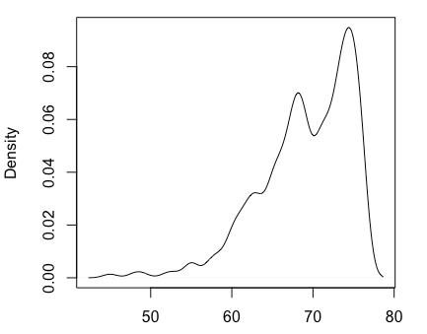

1. Removed subject with WA score of 0.
2. Re-prepped for centering, scaling, and transforming
   1. Word Attack
      1. Lambda: 5.7
   2. Letter-Word
      1. Lambda: 5.28
   3. TOWRE words
      1. Lambda: 1.5
   4. TOWRE nonwords
      1. Lambda: 1.4
3. Executed centering, scaling, and transforming.
4. Created composite using the below formula
   1. tf_data$composite1 <- rowMeans(scale(tf_data[,c("wj3.watt.raw","wj3.wid.raw","towre.w.ipm", "towre.nw.ipm")]))
5. Scaled composite.
6. Centered age.
7. Centered and scaled matrix reasoning and reading comprehension.
8. Ran robust regression (see formula below)
   1. m1 <- rlm(wj3.rcomp.cs ~ age.c + composite1 + wasi.matr.cs, data = data, method = "MM")
9. Standardized predicted values.
10. Chose confidence intervals
    1. 15% within, 65% outside
    2. 25% within, 80% outside
    3. 20% within, 70% outside
11. Obtained residuals.
12. Sorted individuals based on groups due to their residuals and the chosen CIs.
13. Designated subjects with standardized predicted value below -1 as NSC (non-selected)
14. Classified subjects.
    1. 15% within, 65% outside
       1. 43 EAC
       2. 43 UGC
       3. 46 UPC
       4. 202 NSC
       5. Reading comp
          1. UPC < EAC < UGC
       6. Age
          1. No significant difference
       7. Matrices
          1. UPC < EAC
          2. UPC marginally < UGC
          3. UGC = EAC
       8. Decoding composite
          1. No significant difference
    2. 25% within, 80% outside
       1. 80 EAC
       2. 20 UGC
       3. 29 UPC
       4. 205 NSC
       5. Reading comp
          1. UPC < EAC < UGC
       6. Age
          1. No significant difference
       7. Matrices
          1. UPC < EAC
          2. UPC = UGC
          3. UGC = EAC
       8. Decoding composite
          1. No significant difference
    3. 20% within, 70% outside
       1. 63 EAC
       2. 36 UGC
       3. 42 UPC
       4. 193 NSC
       5. Reading comp
          1. UPC < EAC < UGC
       6. Age
          1. No significant difference
       7. Matrices
          1. UPC < EAC
          2. UPC = UGC
          3. UGC = EAC
       8. Decoding composite
          1. No significant difference
    4. 20% within, 60% outside
       1. 63 EAC
       2. 50 UGC
       3. 53 UPC
       4. 168 NSC
       5. Reading comp
          1. UPC < EAC < UGC
       6. Age
          1. No significant difference
       7. Matrices
          1. UPC < EAC
          2. UPC = UGC
          3. UGC = EAC
       8. Decoding composite
          1. No significant difference
    5. 15% within, 70% outside
       1. 43 EAC
       2. 36 UGC
       3. 43 UPC
       4. 213 NSC
       5. Reading comp
          1. UPC < EAC < UGC
       6. Age
          1. No significant difference
       7. Matrices
          1. UPC < EAC
          2. UPC = UGC
          3. UGC = EAC
       8. Decoding composite
          1. No significant difference
    6. 15% within, 65% outside
       1. 43 EAC
       2. 40 UGC
       3. 47 UPC
       4. 205 NSC
       5. Reading comp
          1. UPC < EAC < UGC
       6. Age
          1. No significant difference
       7. Matrices
          1. UPC < EAC = UGC
       8. Decoding composite
          1. No significant difference

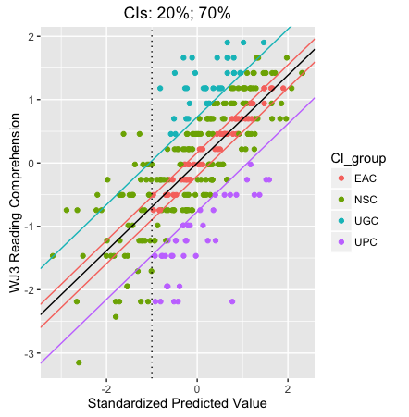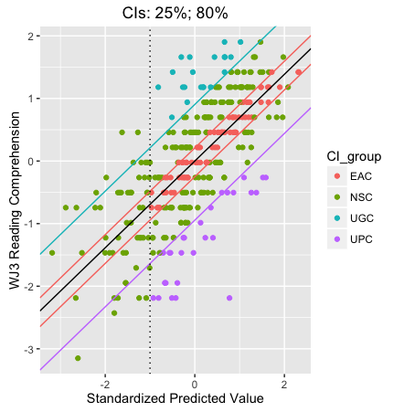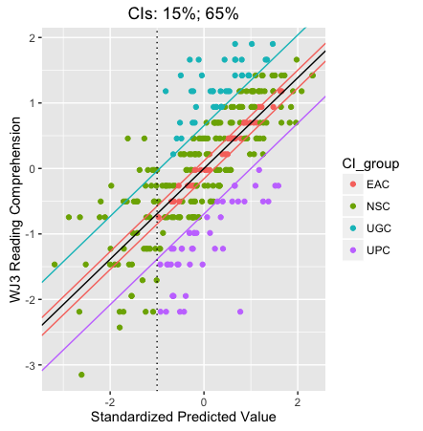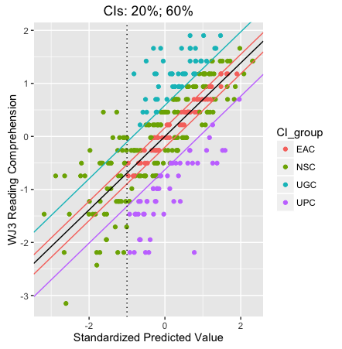



1. Continuing on, re-doing analysis with vocab (WASI).
2. Create data frame with complete cases (n = 329).
3. Centered/scaled predictors and reading comprehension.
4. Re-run analysis, with model including wasi.vocab
   1. 15% within, 65% outside
      1. 62 EAC
      2. 54UGC
      3. 50 UPC
      4. 163 NSC
      5. Reading comp
         1. UPC < EAC < UGC
      6. Age
         1. No significant difference
      7. Matrices
         1. No significant difference
      8. Decoding composite
         1. No significant difference
      9. Vocab
         1. UPC = UGC < EAC
   2. 25% within, 80% outside
      1. 91 EAC
      2. 30 UGC
      3. 31 UPC
      4. 177 NSC
      5. Reading comp
         1. UPC < EAC < UGC
      6. Age
         1. No significant difference
      7. Matrices
         1. UPC marginally < EAC = UGC
      8. Decoding composite
         1. No significant difference
      9. Vocab
         1. UPC = UGC < EAC
   3. 20% within, 70% outside
      1. 78 EAC
      2. 46 UGC
      3. 44 UPC
      4. 161 NSC
      5. Reading comp
         1. UPC < EAC < UGC
      6. Age
         1. No significant difference
      7. Matrices
         1. No significant difference
      8. Decoding composite
         1. No significant difference
      9. Vocab
         1. UPC = UGC < EAC
   4. 20% within, 60% outside
      1. 78 EAC
      2. 61 UGC
      3. 54 UPC
      4. 136 NSC
      5. Reading comp
         1. UPC < EAC < UGC
      6. Age
         1. No significant difference
      7. Matrices
         1. No significant difference
      8. Decoding composite
         1. No significant difference
      9. Vocab
         1. UPC = UGC
         2. UPC = EAC
         3. UGC < EAC
   5. 15% within, 70% outside
      1. 62 EAC
      2. 46 UGC
      3. 44 UPC
      4. 177 NSC
      5. Reading comp
         1. UPC < EAC < UGC
      6. Age
         1. No significant difference
      7. Matrices
         1. No significant difference
      8. Decoding composite
         1. No significant difference
      9. Vocab
         1. UPC = UGC < EAC
   6. 15% within, 65% outside
      1. 62 EAC
      2. 54 UGC
      3. 50 UPC
      4. 163 NSC
      5. Reading comp
         1. UPC < EAC < UGC
      6. Age
         1. No significant difference
      7. Matrices
         1. No significant difference
      8. Decoding composite
         1. No significant difference
      9. Vocab
         1. UPC = UGC < EAC

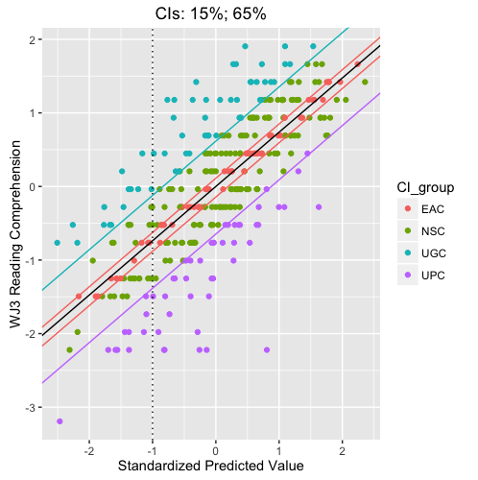 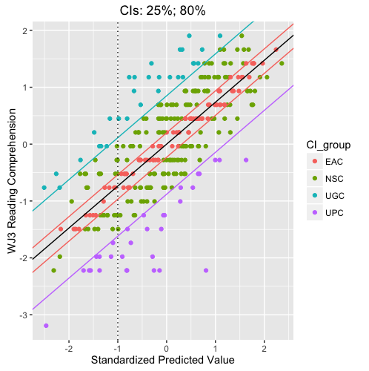 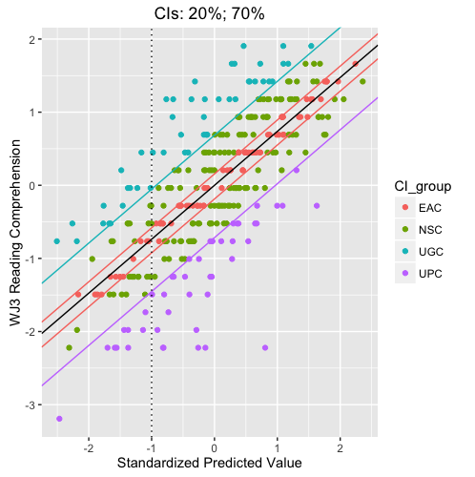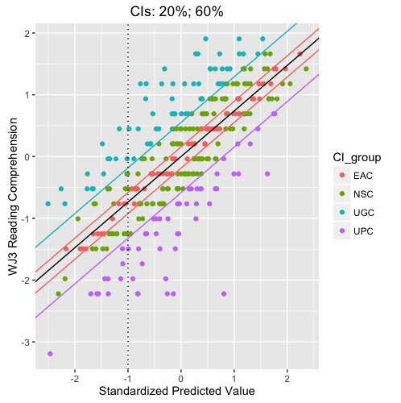

1. Re-run analysis, with model replacing wasi.vocab with wj3.oralcomp
   1. 15% within, 65% outside
      1. 49 EAC
      2. 50 UGC
      3. 50 UPC
      4. 178 NSC
      5. Reading comp
         1. UPC < EAC < UGC
      6. Age
         1. No significant difference
      7. Matrices
         1. No significant difference
      8. Decoding composite
         1. No significant difference
      9. Oral comp
         1. UGC < EAC
         2. UPC = UGC
         3. UPC = EAC
   2. 25% within, 80% outside
      1. 90 EAC
      2. 36 UGC
      3. 38 UPC
      4. 163 NSC
      5. Reading comp
         1. UPC < EAC < UGC
      6. Age
         1. No significant difference
      7. Matrices
         1. UGC < EAC
         2. UPC = UGC
         3. UPC = EAC
      8. Decoding composite
         1. UGC < EAC
         2. UPC = UGC
         3. UPC = EAC
      9. Oral comp
         1. UGC < EAC
         2. UPC = UGC
         3. UPC = EAC
   3. 20% within, 70% outside
      1. 67 EAC
      2. 42 UGC
      3. 45 UPC
      4. 173 NSC
      5. Reading comp
         1. UPC < EAC < UGC
      6. Age
         1. No significant difference
      7. Matrices
         1. UGC < EAC
         2. UPC = UGC
         3. UPC = EAC
      8. Decoding composite
         1. UGC < EAC
         2. UPC = UGC
         3. UPC = EAC
      9. Oral comp
         1. UGC < EAC
         2. UPC = UGC
         3. UPC = EAC
   4. 20% within, 60% outside
      1. 67 EAC
      2. 55 UGC
      3. 65 UPC
      4. 140 NSC
      5. Reading comp
         1. UPC < EAC < UGC
      6. Age
         1. No significant difference
      7. Matrices
         1. No significant difference
      8. Decoding composite
         1. No significant difference
      9. Oral comp
         1. UGC < EAC
         2. UPC = UGC
         3. UPC = EAC
   5. 15% within, 70% outside
      1. 62 EAC
      2. 46 UGC
      3. 44 UPC
      4. 177 NSC
      5. Reading comp
         1. UPC < EAC < UGC
      6. Age
         1. No significant difference
      7. Matrices
         1. No significant difference
      8. Decoding composite
         1. UGC marginally < EAC (.055)
         2. UPC = EAC
         3. UPC = UGC
      9. Oral comp
         1. UGC < EAC
         2. UPC = UGC
         3. UPC = EAC

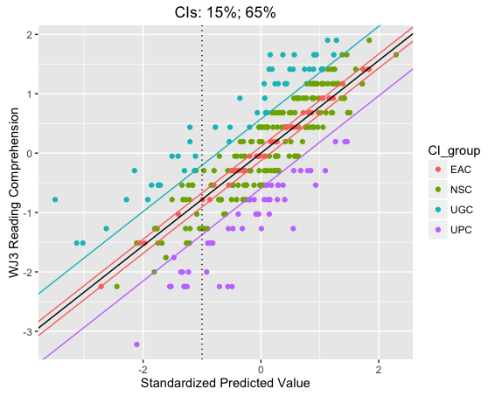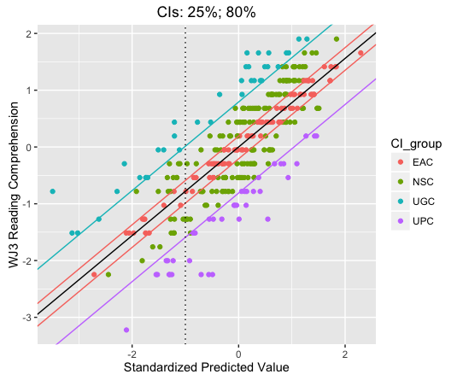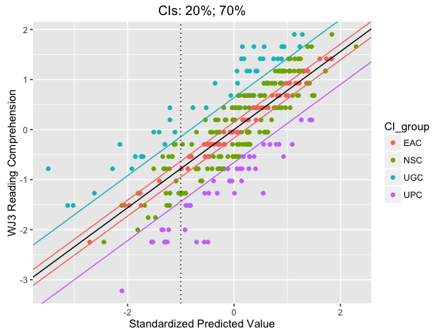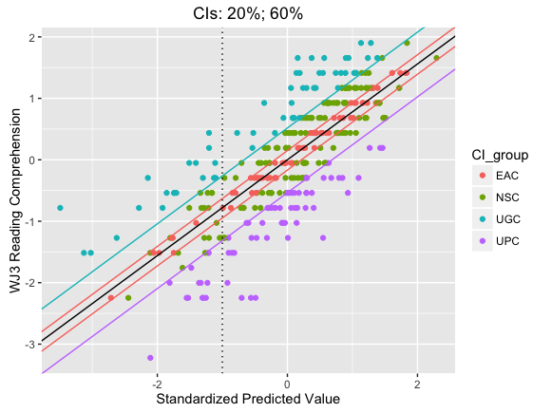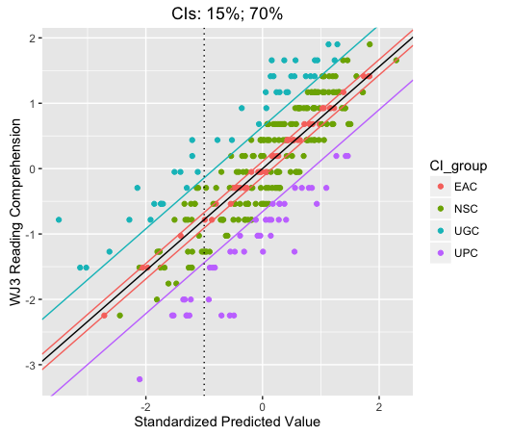

1. Re-ran analysis with PPVT (and matrix reasoning and decoding composite)
   1. 15% within, 65% outside
      1. 43 EAC
      2. 37 UGC
      3. 46 UPC
      4. 193 NSC
      5. Reading comp
         1. UPC < EAC < UGC
      6. Age
         1. No significant difference
      7. Matrices
         1. UPC < EAC
         2. UPC = UGC
         3. UGC = EAC
      8. Decoding composite
         1. No significant difference
      9. Vocabulary (PPVT)
         1. UPC < UGC = EAC
   2. 20% within, 60% outside
      1. 61 EAC
      2. 45 UGC
      3. 53 UPC
      4. 160 NSC
      5. Reading comp
         1. UPC < EAC < UGC
      6. Age
         1. No significant difference
      7. Matrices
         1. No significant difference
      8. Decoding composite
         1. No significant difference
      9. Vocabulary (PPVT)
         1. UPC < EAC < UGC

 

1. Re-ran analysis with PPVT (and matrix reasoning and decoding composite) – using regular linear model, not robust
   1. 15% within, 65% outside
      1. 43 EAC
      2. 37 UGC
      3. 46 UPC
      4. 193 NSC
      5. Reading comp
         1. UPC < EAC < UGC
      6. Age
         1. No significant difference
      7. Matrices
         1. No significant difference
      8. Decoding composite
         1. No significant difference
      9. Vocabulary (PPVT)
         1. No si
   2. 20% within, 60% outside
      1. 46 EAC
      2. 40 UGC
      3. 49 UPC
      4. 180 NSC
      5. Reading comp
         1. UPC < EAC < UGC
      6. Age
         1. No significant difference
      7. Matrices
         1. No significant difference
      8. Decoding composite
         1. No significant difference
      9. Vocabulary (PPVT)
         1. No significant difference

 